Australia Geography Webquest

Australia and Oceania: Physical Geography https://goo.gl/LiIXcp
1. What is Oceania? ______________________________________________________________

2. Oceania includes what 2 continents? ____________________________________________. It also includes three island regions: __________________, _______________, and ______________________ (including the U.S. state of Hawaii).

3. What are the three ways island groups can be divided? Describe or draw a picture of each below.

4. What makes the Great Barrier Reef Special? ______________________________________________ __________________________________________________________________________________________________________________________________________________________________________

The Australian Continent https://goo.gl/wQwhwJ
5. Give two details about the Australian continent: __________________________________________ _____________________________________________________________________________________

6. What is the size of Australia compared to the United States? _______________________ It is also the _________, the _____________________and (apart from Antarctica) the _____________.

7. How much of Australia's land mass is classified as desert? ___________

8. What types of climates does Australia have? (Complete the chart with a picture of each climate)

Australia: Our Natural Environment https://goo.gl/lkqoqX
9. Australia is the __________largest country in the world.

10. Where does 80% of the population live? ____________________________.

11. Only _____ per cent of the Australian landmass is arable. (Arable - land that is good for growing crops).

13. Australia is the _____________ inhabited continent on earth, with the least amount of water in _________. How do you think this would affect life in Australia? ________________________________ ________________________________________________________________________________________

14. Australia is one of the most biologically ______________ countries on the planet. What does this mean?___________________________________________________________________________________________________________________________________________________________________________

15. Use these maps: https://goo.gl/gS5d1R https://goo.gl/KHlkSm
Use 4 colors to show the environments on the map below & be sure to make a KEY!
Use the population map to locate & label the 4 largest cities in Australia.
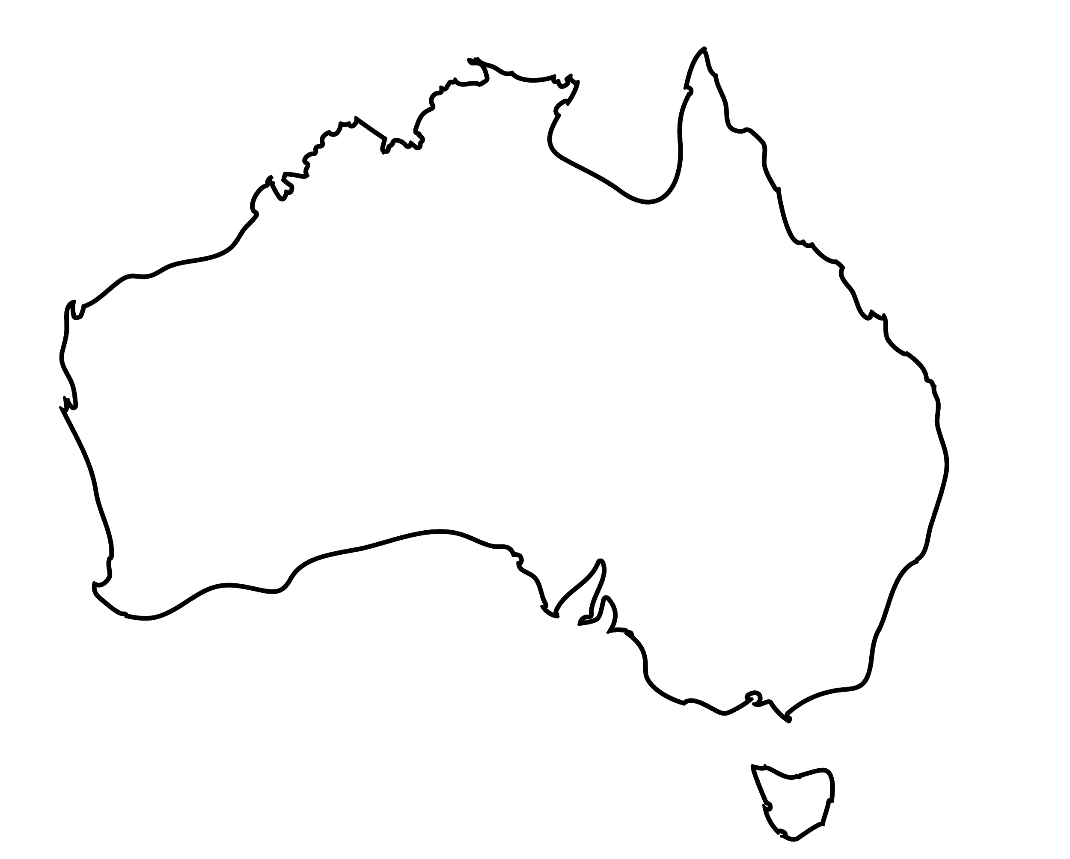 | KEY

16. Based on the environment map, why do you think people live along the coast in Australia? ________________________________________________________________________________________ ________________________________________________________________________________________

Australia Government & Economy Webquest

Australia’s Government: https://goo.gl/PBsBAS
- What is the official name of Australia?_______________________________________________
- What form of government does it have?______________________________________________
- When was the Commonwealth of Australia formed?___________
- What are the three “arms” of Australia’s government? __________________________________ _____________________________________________________________________________
- Is this similar or different to the US? ____________________ How so?_____________________ _____________________________________________________________________________

Look at the top three images found here: https://goo.gl/13sSf7
- What does each branch of their government do?
Legislative (Parliament) | Executive | Judiciary

Australia’s Economy: https://goo.gl/tzwV77
- Give 3 facts of the following top industries in Australia:
Manufacturing | Natural Resources | Agriculture
.

The Wool Industry https://goo.gl/5oPosq & https://goo.gl/JMbrnc
- Write down 3 things you learned from these videos

Australia’s GDP Composition https://goo.gl/gSLIv0
Draw the graph on the circle below & make a KEY! →

- What industry makes up most of Australia’s GDP?

______________________________________

Service Skills Australia https://goo.gl/aFzx6t
- How many people work in the service industry? _____________________________________
- Give 3 examples of service areas that someone could work:

- Click on one of the service areas. Which did you choose? _______________________________

- What are two examples of jobs someone would be doing if they worked in this area?

Australia’s Industries https://goo.gl/3yWwLp https://goo.gl/tYGvEV
- What are the top 3 exports?

- What industry would you categorize these 3 exports? _________________________________
- Where do most of Australia’s exports go? _____________________________________________
- What two minerals are most important to New South Wales?

- Which state do you think is most important to Australia’s mining industry? _______________ Explain why, using evidence: ______________________________________________________________________________________________________________________________________________________________
- What is Australia’s top import? ______________________________________________________

Australian Tourism https://goo.gl/Brv1aq
- Watch the tourism video. Which of the places shown would you most like to go? Why? (and don’t say “because it’s fun”).

